Aror University of Art, Architecture, Design & Heritage Sukkur

Department of AI

|  |  |
| --- | --- |
| Name : Heeranand | Assignment As : Lab 06 |
| Roll No: Ari –F23-0096 | Submitted To : Sir Abdul Ghafoor |

**LeetCode**

TASK NO 1:

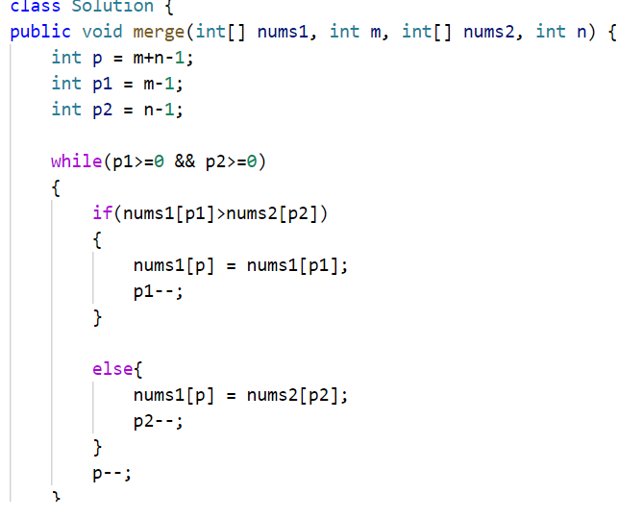

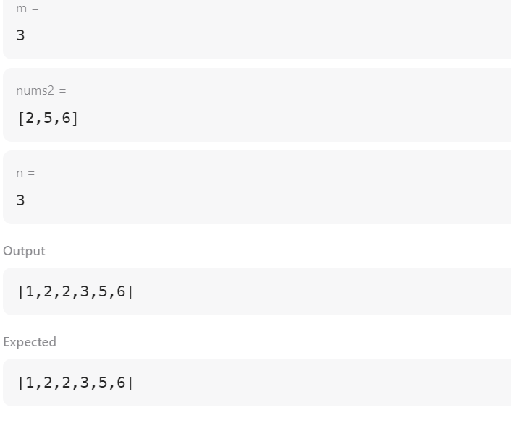

TASK 2

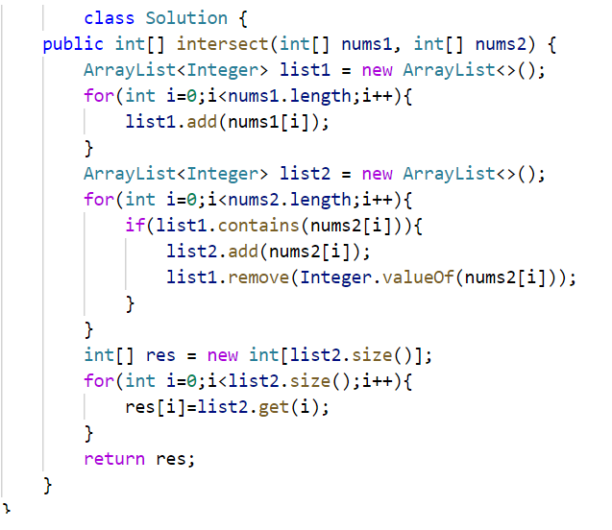

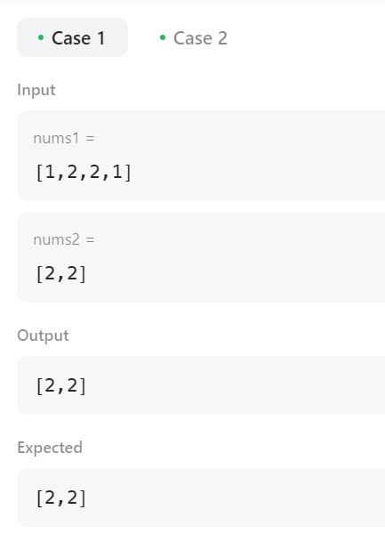

**TASK 03**

